**COLLEGE MANAGEMENT SYSTEM**

INTRODUCTION

• college database management system manages details of all the Students

including Batch , Course and Enrollment.

• Keep track of all of its students and class their addmisions accordingly.

• Store and retrieve information about various students related to college

Admission and details of students

• Maintaining records of students addmisions in the different dates.

SCOPE OF STUDIES

• All the manual work should be converted and computerized so that the

manual work of employees will be reduced.

• The database should be stored in a computer rather than storing all the

records manually.

• Introducing a new online admissions system is not only technological

innovation but also will improve the college services to a certain extent. It

solves the difficult problems of students addmisions.

FEATURES

• Surfing data is easy.

• The wait time of students will be reduced.

• Accuracy of the information.

• It is a fast process.

• Data is efficient.

These are the following entities that are related to college student.

• STUDENT

• COURSE

• BATCH

• ENROLLMENT

1.STUDENTS and its attributes

• S_ID CHAR PRIMARY KEY

• S_NAME VARCHAR

• S_DOB DATE

• S_CITY VARCHAR

• S_EMAIL VARCHAR

• S_PHONE VARCHAR

• S_QUAL VARCHAR

2. COURSE and its attributes.

• COURSE_ID CHAR PRIMARY KEY

• COURSE_NAME VARCHAR

• COURSE_CATEGORY VARCHAR

• COURSE_FEES DECIMAL

• COURSE_DURATION INT

3. BATCH and its attributes.

• BATCH_ID CHAR PRIMARY KEY

• BS_DATE DATETIME

• BS_TRENGTH INT

• COURSE_ID CHAR FOREIGN KEY

4. ENROLLMENT and its attributes

• BATCH_ID CHAR

• E_DATE DATE

• S_ID CHAR

FOREIGN KEY (S_ID) REFERENCES STUDENT(S_ID),

FOREIGN KEY (BATCH_ID) REFERENCES BATCH(BATCH_ID)

**TABLES CREATION AND DATA DICTIONARY**

**1.CREATE DATABASE COLLEGE_STUDENT**

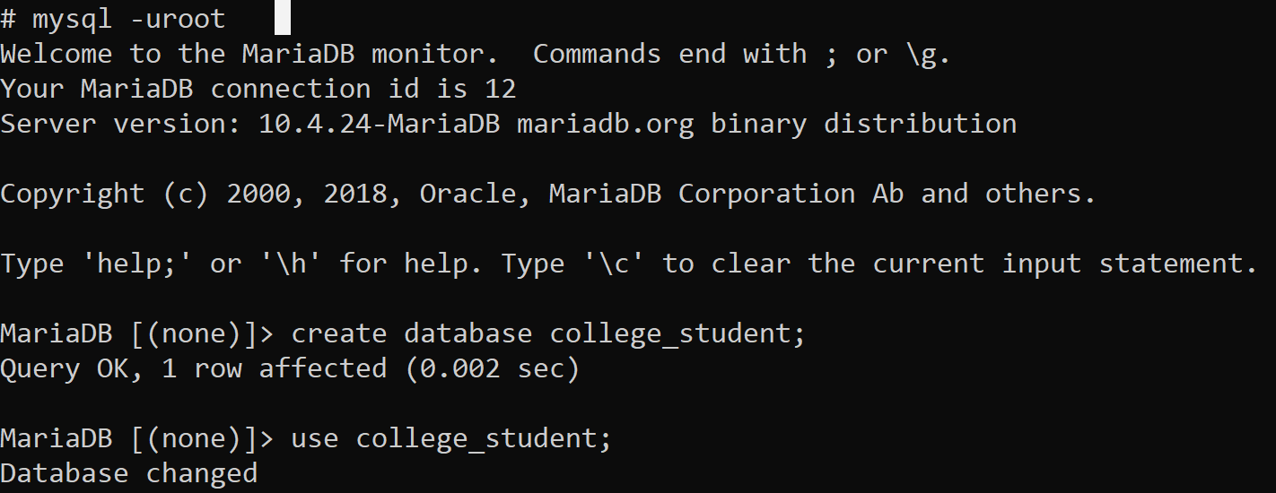

**2. ADDING TABLE STUDENT TO DATABASE**

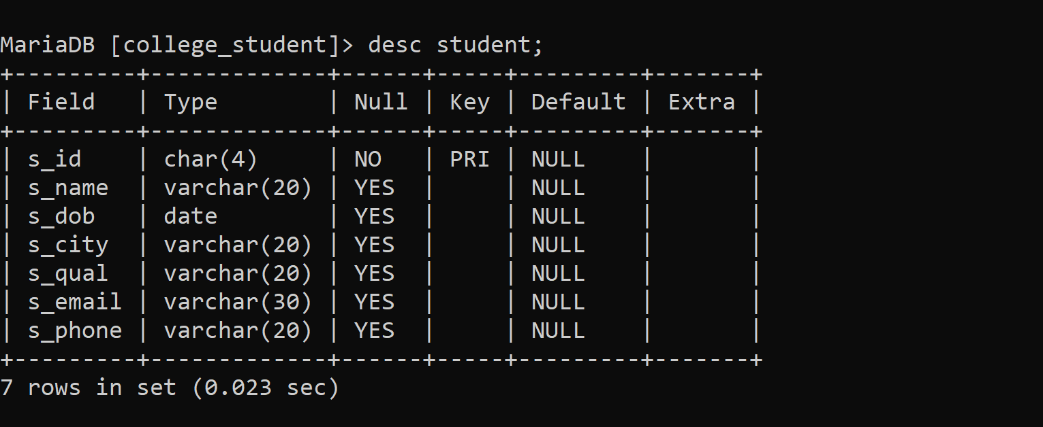

**3. ADDING TABLE COURSE TO DATABASE**

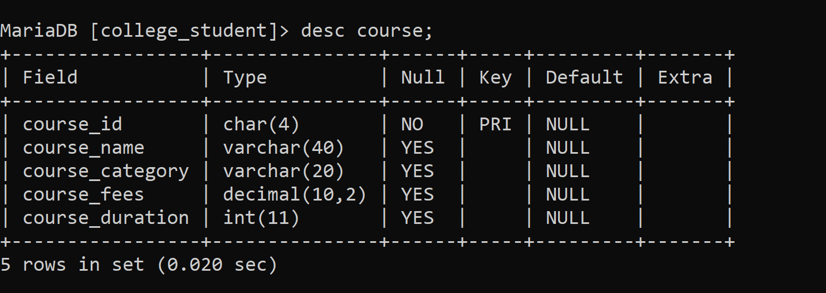

**4. ADDING TABLE BATCH TO DATABASE**

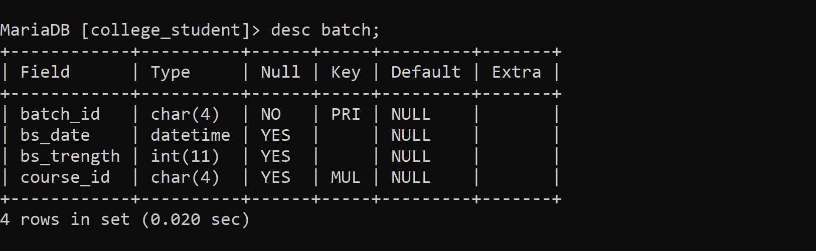

**5. ADDING TABLE ENROLLMENT TO DATABASE**

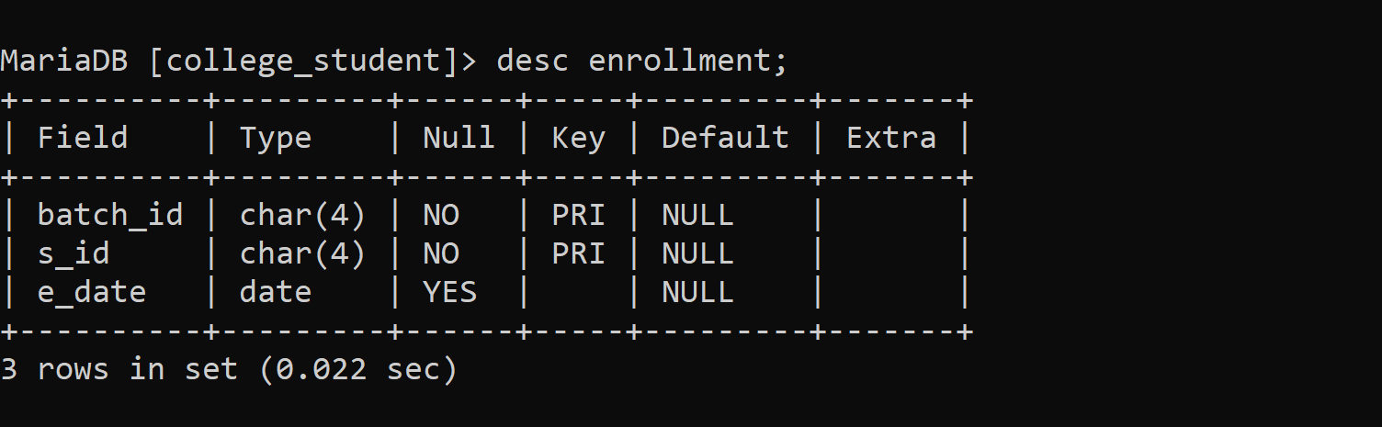

**6.ADDING TABLE TRANSACTION_REPORT TO DATABASE**

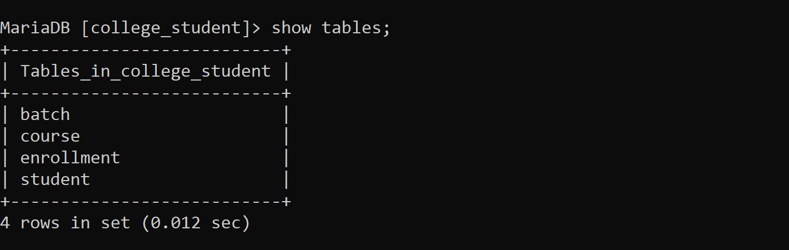

**INSERTING VALUES INTO TABLES**

**1.SELECT * FROM STUDENT**

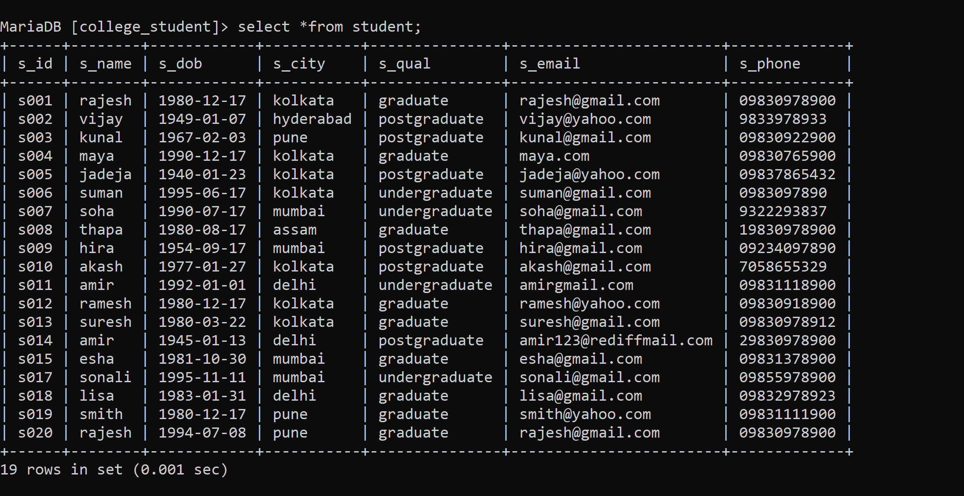

**2.SELECT * FROM COURSE**

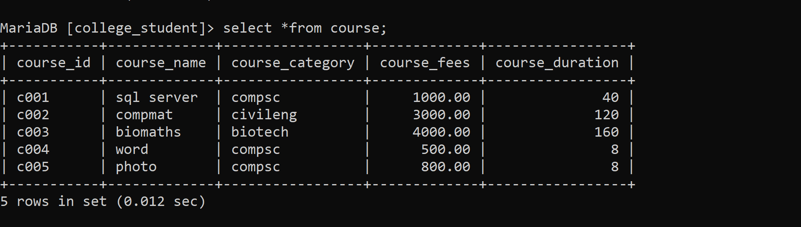

**3.SELECT * FROM BATCH**

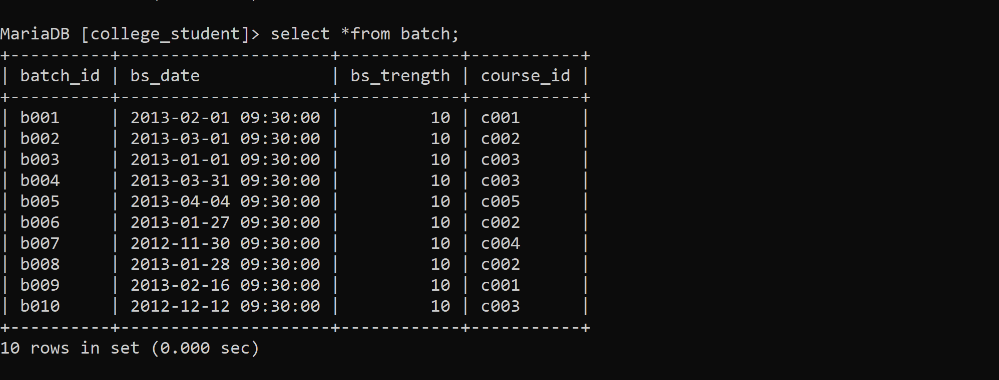

**4.SELECT * FROM ENROLLMENT**

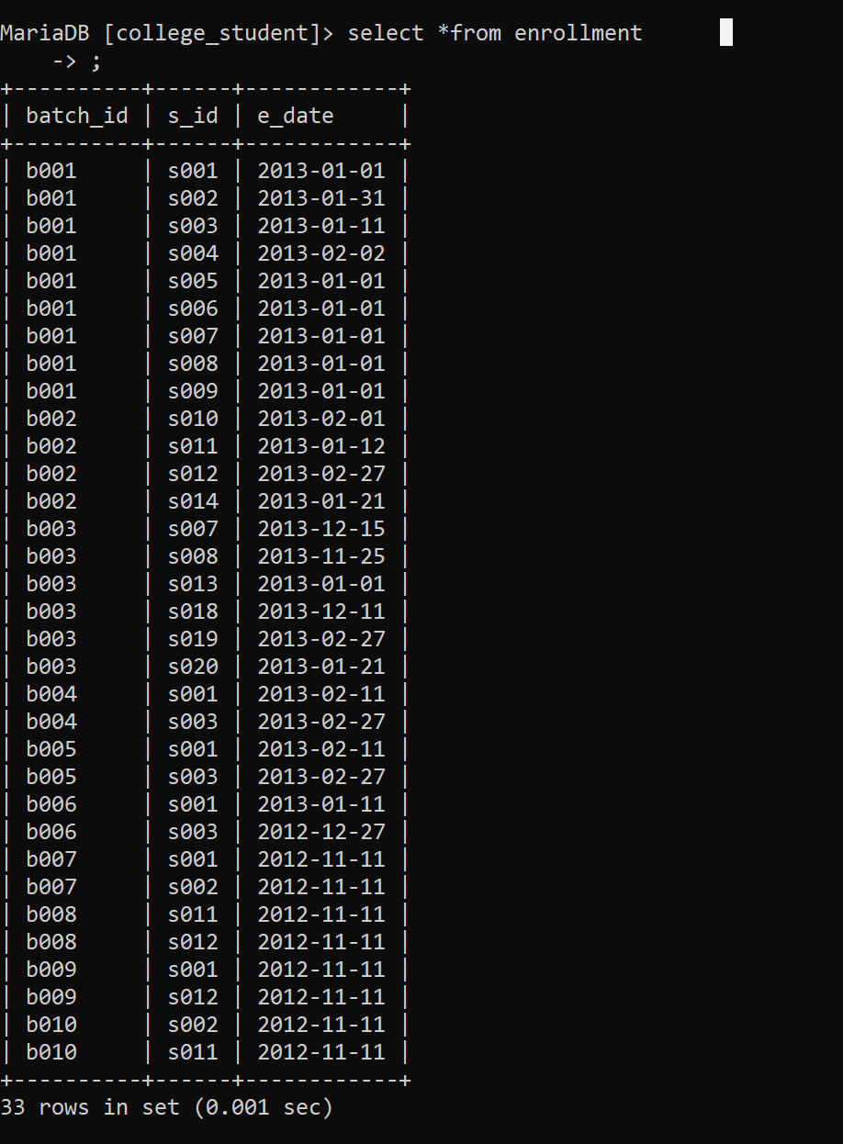

**SUB QUERIES**

1.Write a query from student table whose city is KOLKATA.

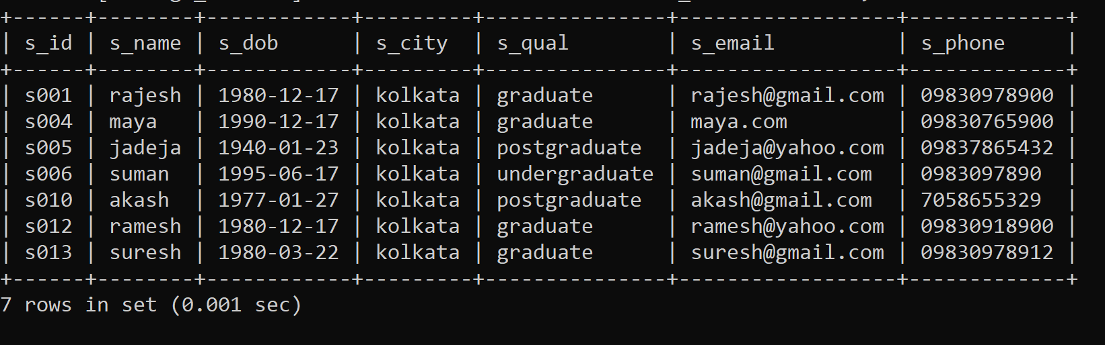

2. Write a query from student table whose city is KOLKATA and Qualification is graduate.

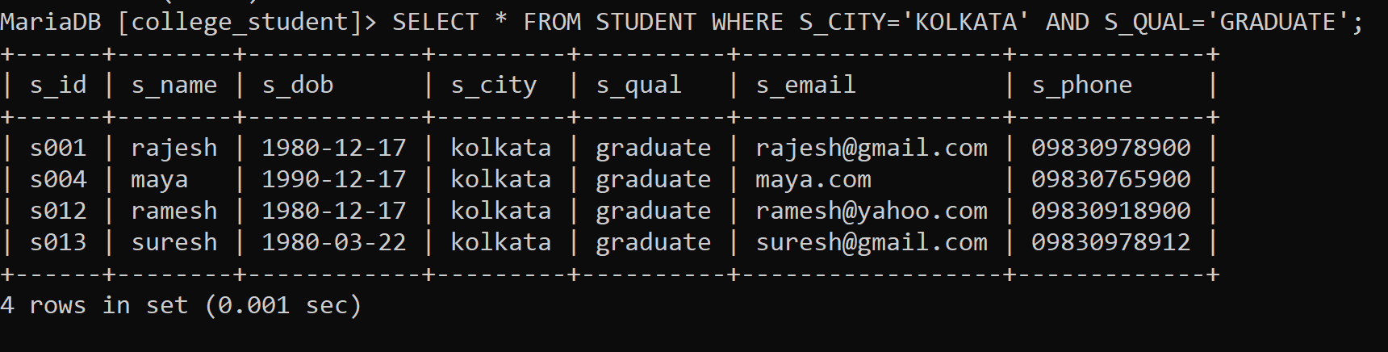

3.Write a query will return all the students whose city is pune or Qualification is Postgradute.

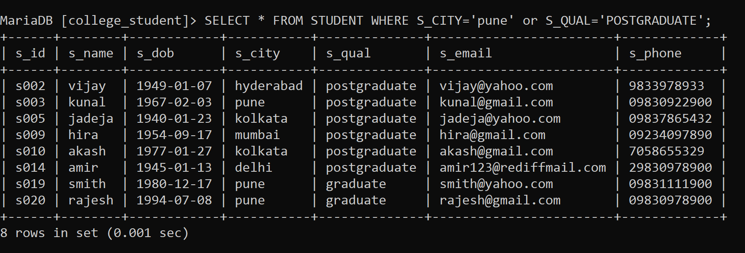

**4**. Count the total number of students from student table.

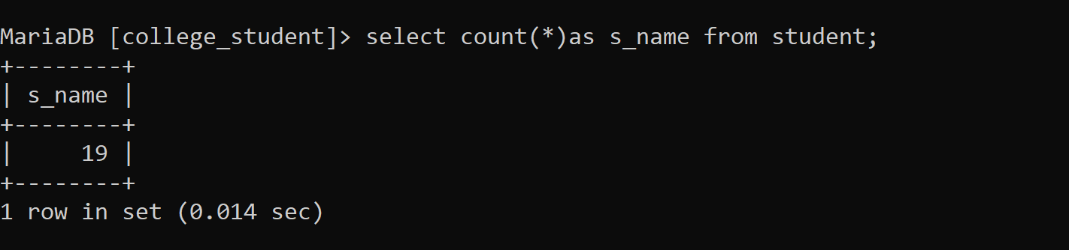

5. Find the highest fees in course of college.

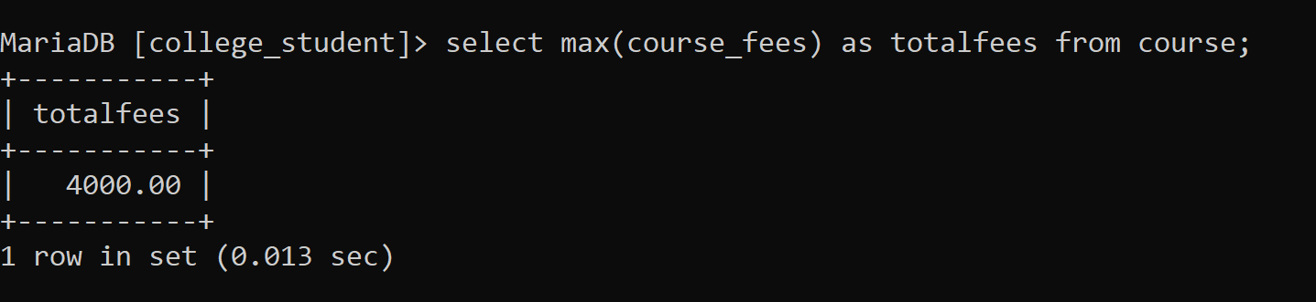

6.Find the total fees given to all course.

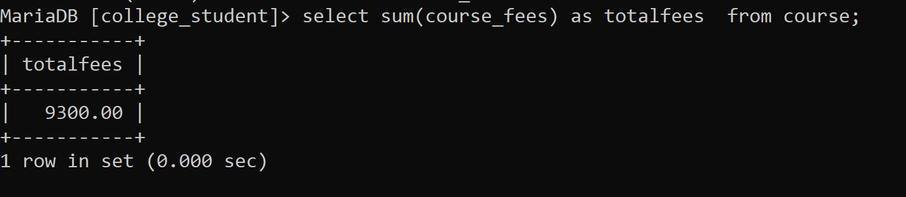

7.Count the total number of courses in the course table.

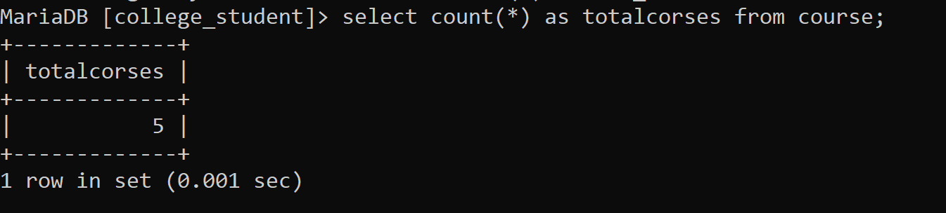

8. Display WHOLE DATA of the student starting from LETTER S.

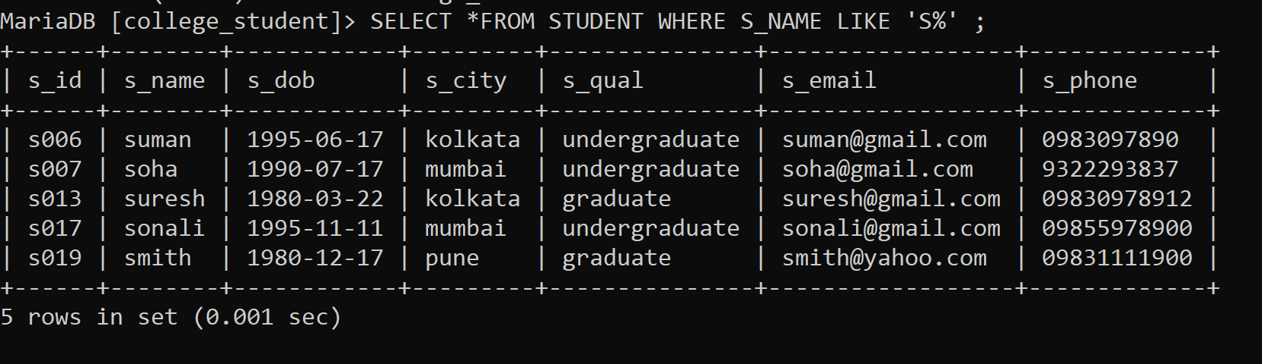

9. Display WHOLE DATA of STUDENT ID IS 'S002'.

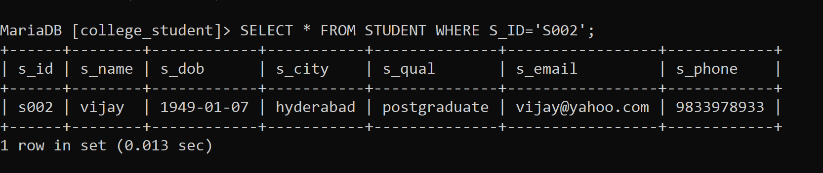

10.DISPLAY FIRST 5 STUDENTS DETAILS.

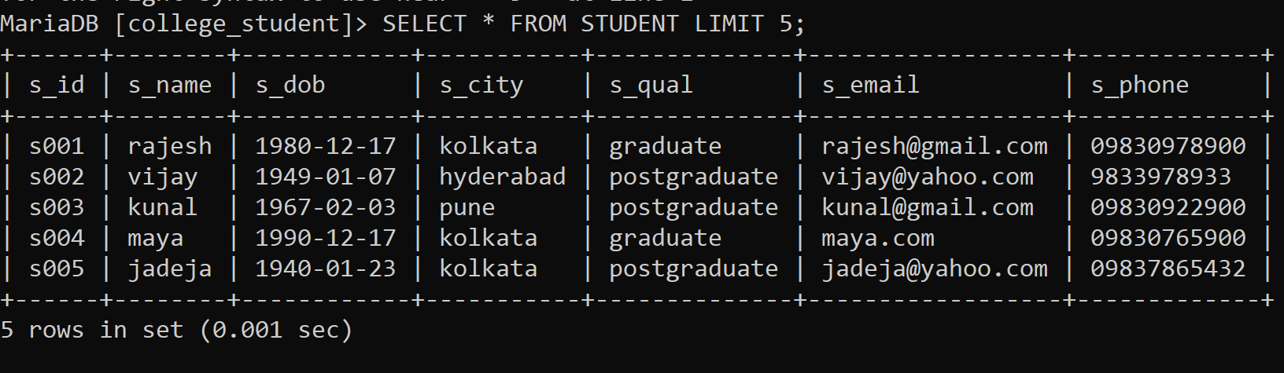

11.DISPLAY ONLY POSTGARDUATE STUDNET WITH DETAILS.

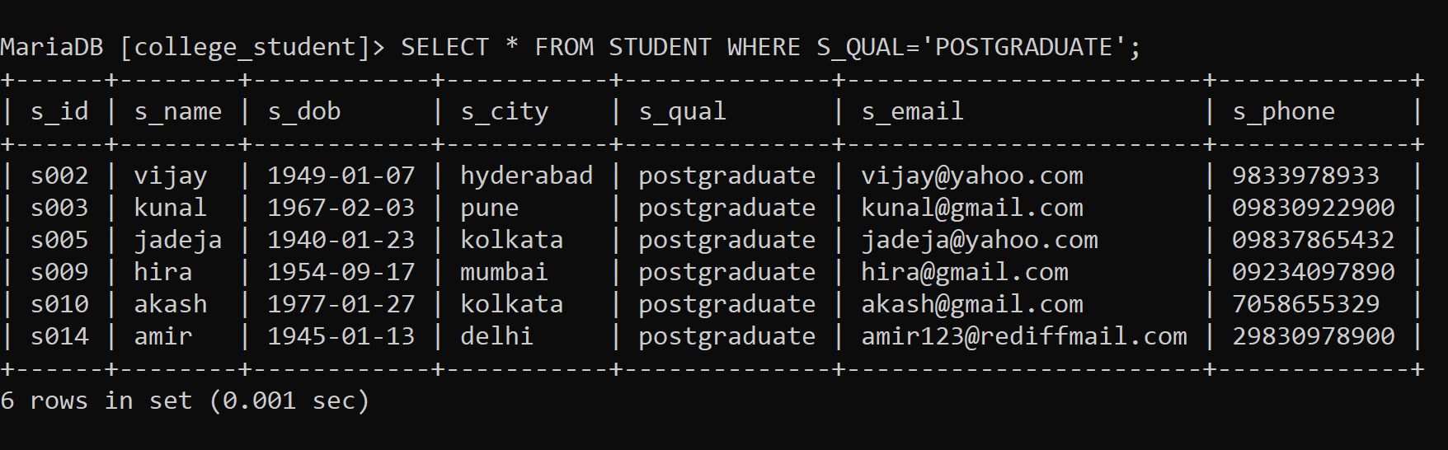

12.DISPLAY SRUDENTS DETAILS IN ASCENDING ORDER.

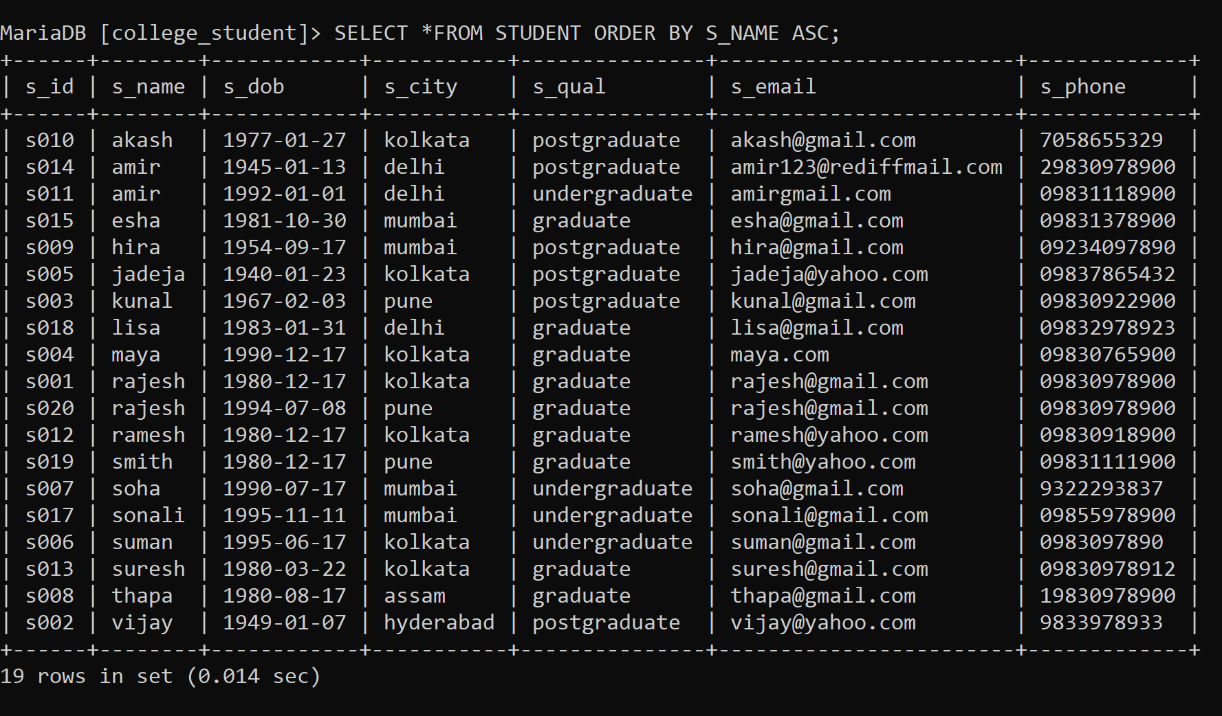

13. DISPLAY THE RECORD OF STUDENT HAVING DATE OF BIRTH IS

11-11-1995

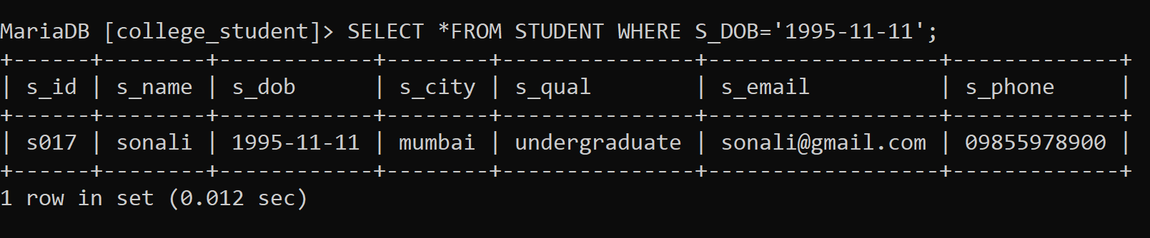

14. CHANGE THE CONTACT NUMBER OF STUDENT HIRA.

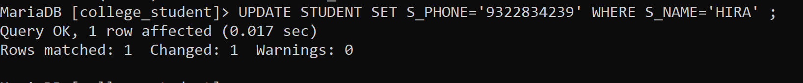

15. FIND STUDENT ENROLLMENT DATE WHOSE STUDENT ID IS S005.

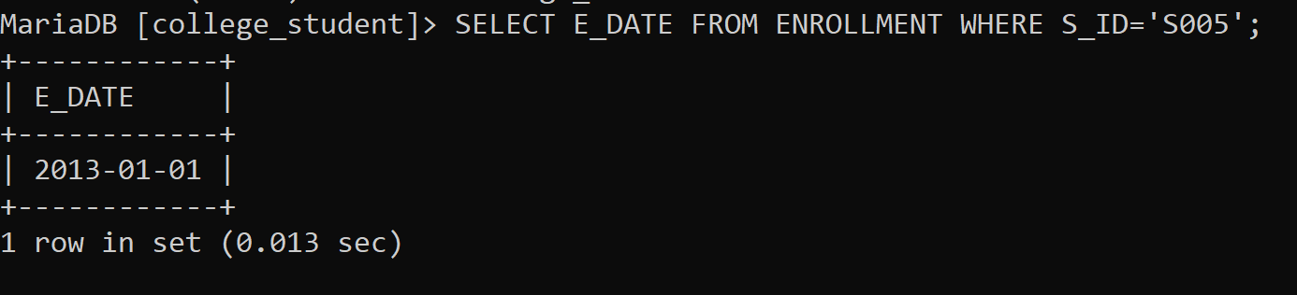

16. DISPLAY THE COURSE NAME OF HAVING COURSE CATEGORY IS COMPSC.

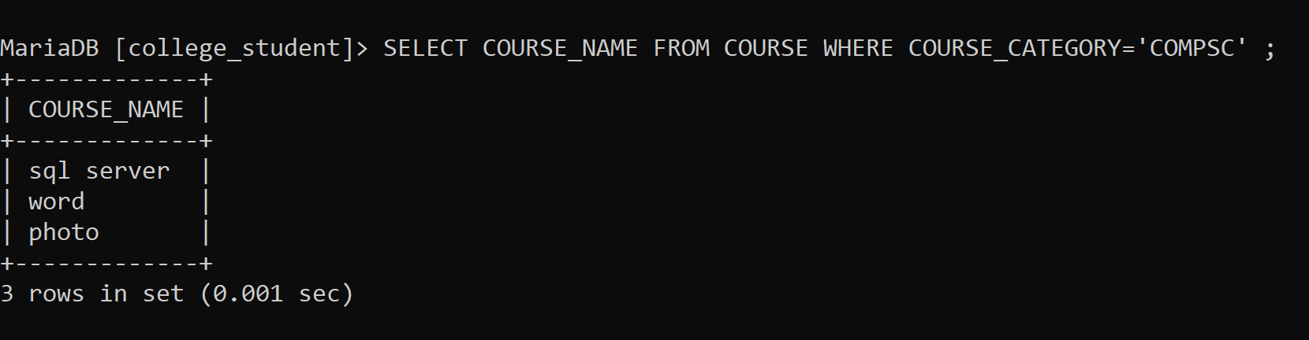

17. DISPLAY BATCH START DATE WHOSE COURSE ID 'C005'.

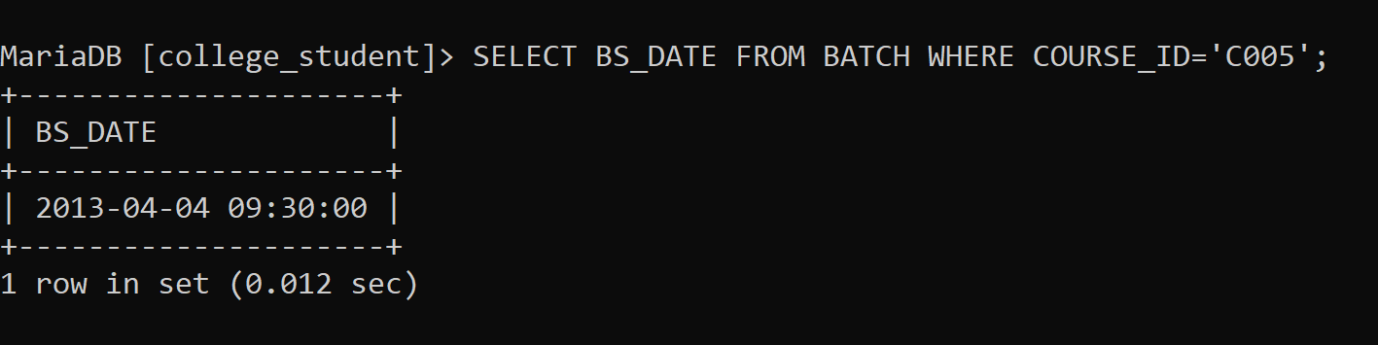

**JOINS**

**1.INNER JOIN**

**QUERY….**

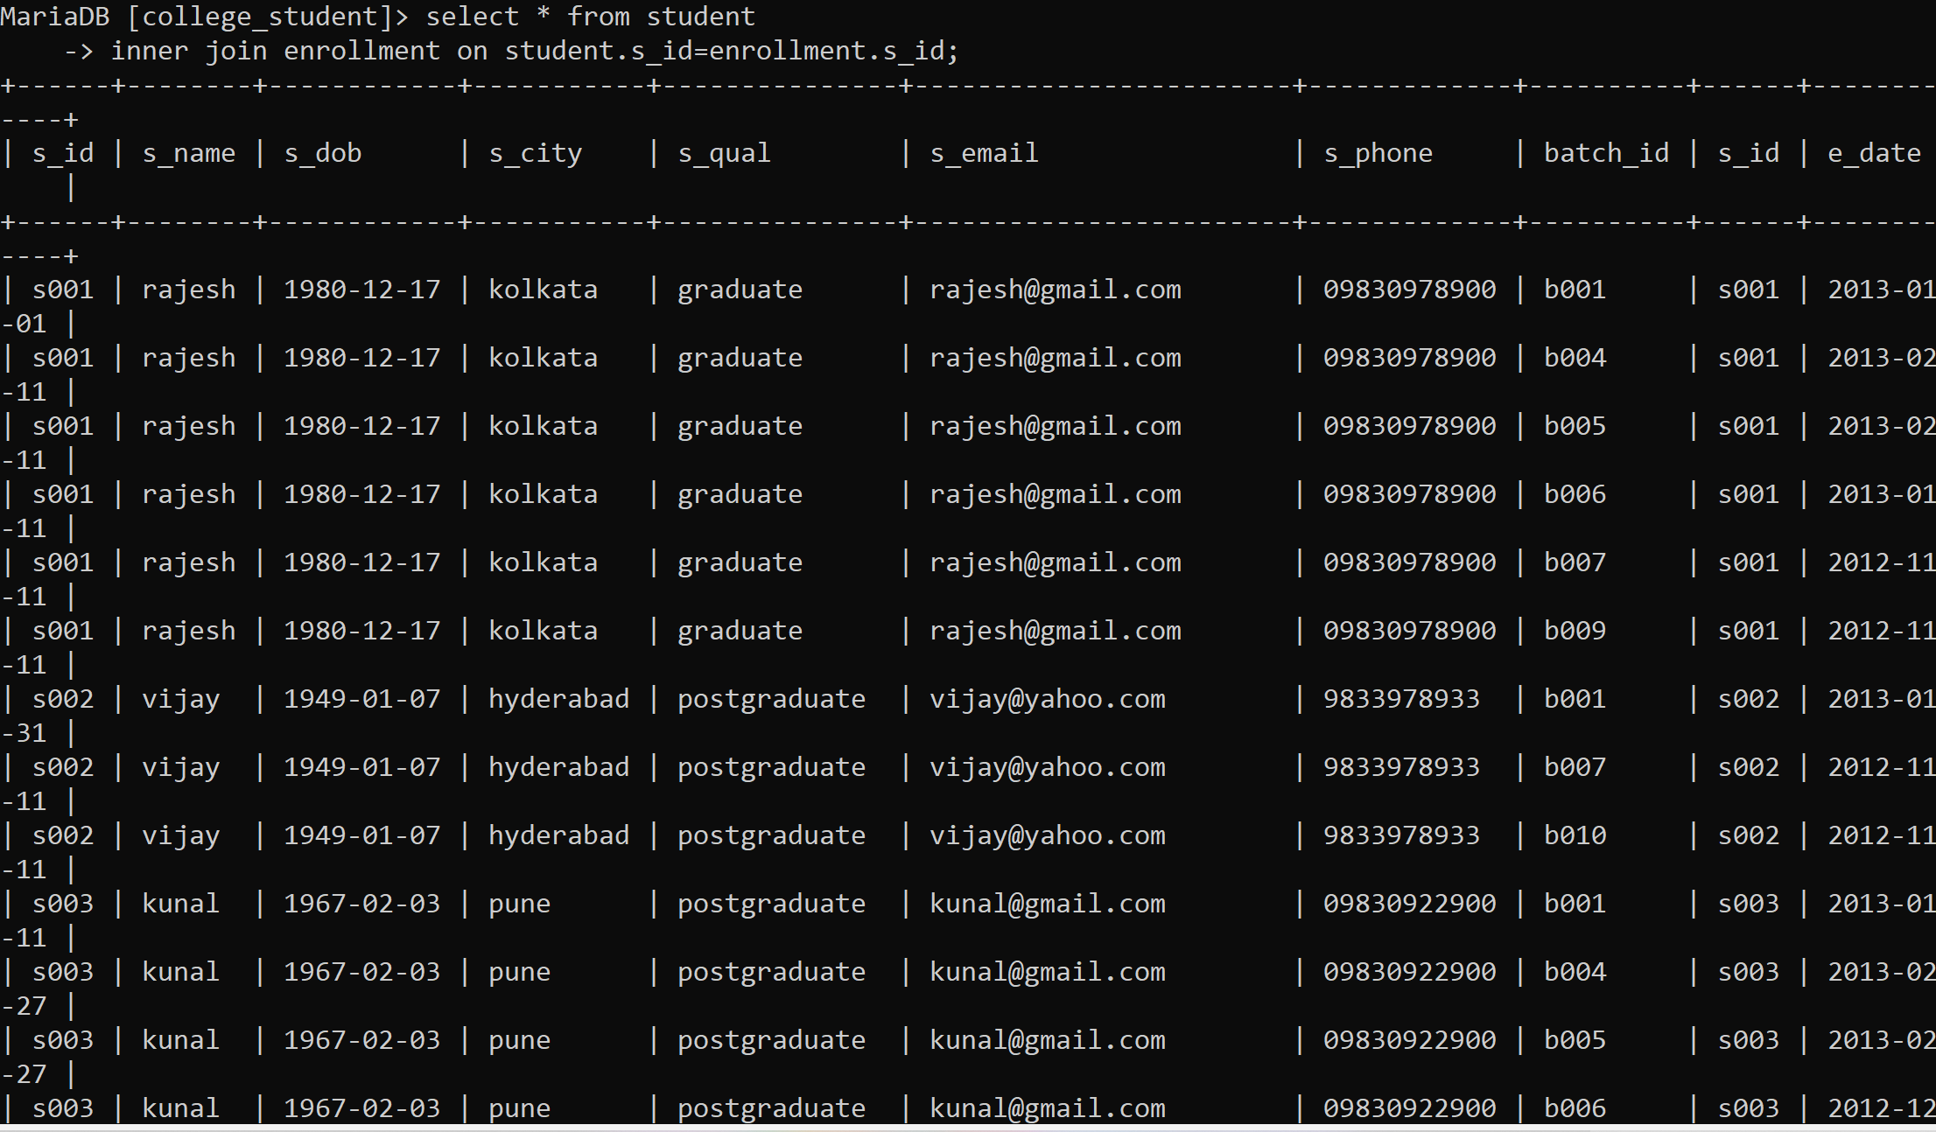

2.LEFT JOIN

QUERY..

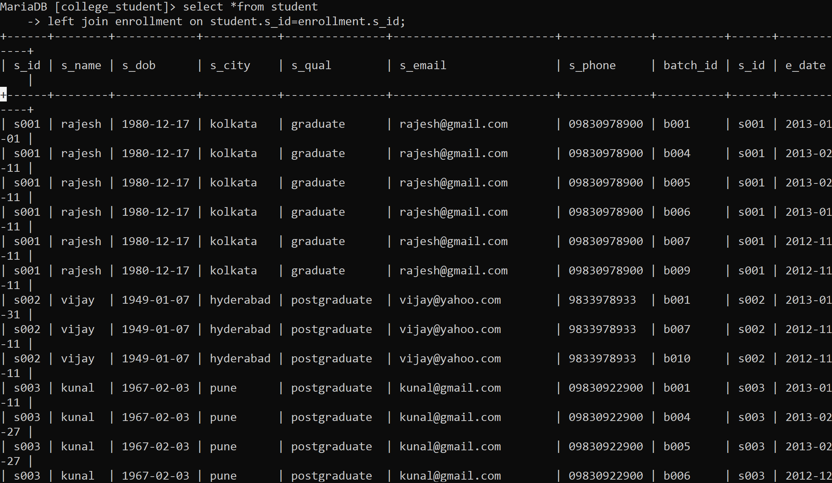

**VIEWS**

**CREATE VIEW GRADUATION_STUDENTS**

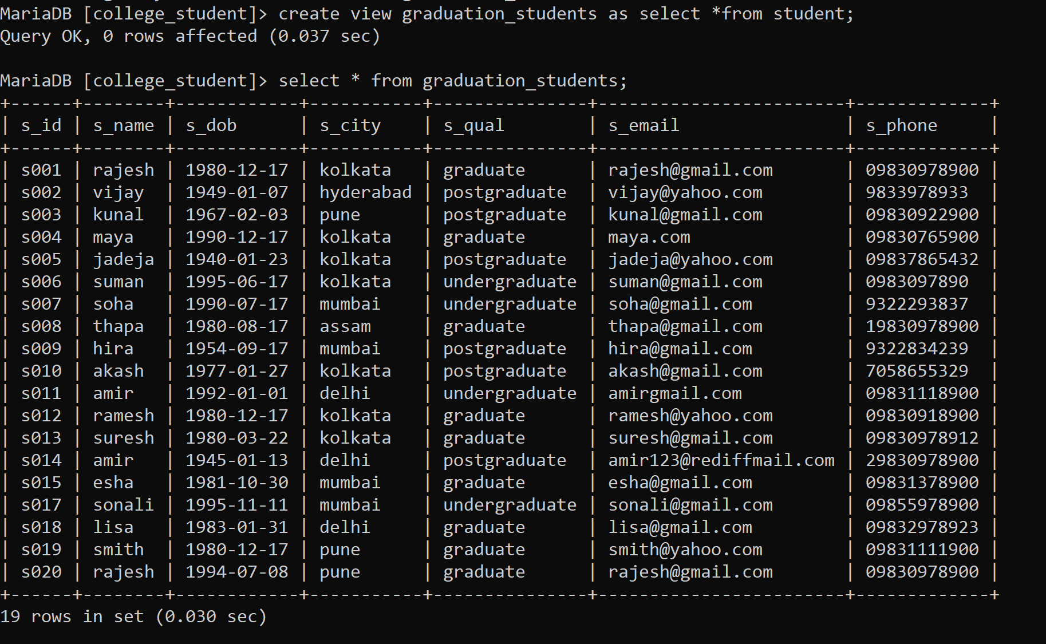

**CREATE VIEW STUDENT_NAME**

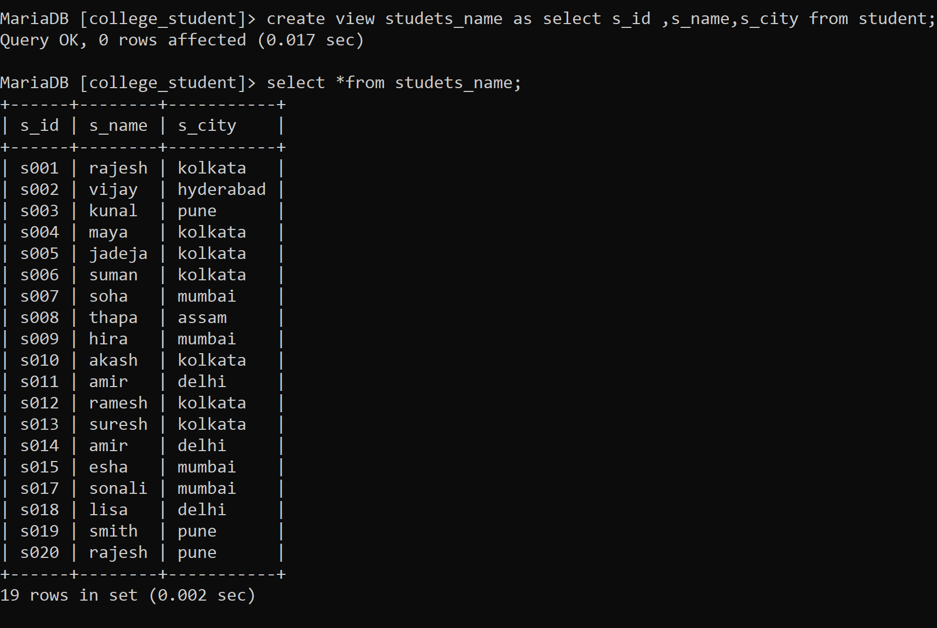

**Observation or Conclusion:**

• The main purpose of maintaining this database for the college

management system is to reduce the error involved in

addmission and make it convenient for students and to maintain

the data about Students, Courses and Batches.

• By making an online application, many loopholes that exist in

manual maintenance of the records can be removed.

• The speed of obtaining data will be fast.

• • •